EXPERIMENT NO. 5 / 6
UML Use Case Diagram & Class Diagram
Project: Hospital Management System (HMS)
Prepared by: Anish Chitnis (24CE1044) | Aaryan Choube (24CE1045) | Somansh Dafade (24CE1047)
Batch: A / A1 | Dept of Computer Engineering, RAIT, DY Patil University
1. Aim
To identify system operational scenarios and develop the UML Use Case Diagram and Class Diagram for the Hospital Management System (HMS), defining actors, use case relationships, class hierarchies, associations, aggregations, and compositions.
2. Objectives
• To model user interactions and functional boundaries using UML Use Case notations.
• To apply <<include>> (mandatory prerequisite) and <<extend>> (optional branch) stereotypes accurately.
• To construct an object-oriented static model via a UML Class Diagram showing attributes, operations, and visibility.
• To represent advanced relationships: Generalization (Inheritance), Aggregation (Hollow diamond), and Composition (Filled diamond).
3. UML Use Case Diagram
The Use Case Diagram captures the functional requirements from the perspective of external actors interacting with the HMS system boundary.
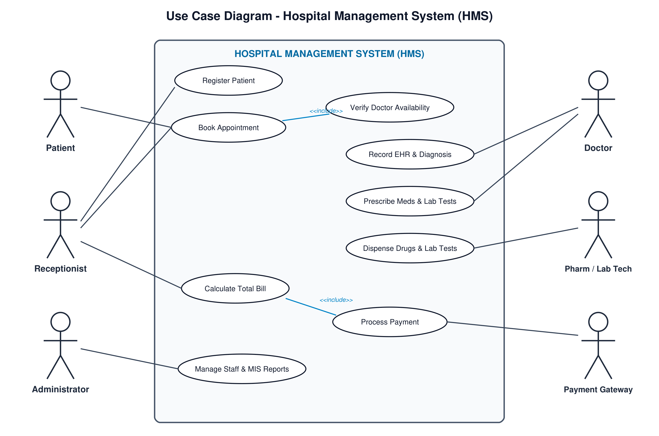
Fig 1: Use Case Diagram - Hospital Management System (HMS)
Key Use Case Stereotypes & Rationale:
• <<include>> relationship: 'Book Appointment' includes 'Verify Doctor Availability'. The appointment booking workflow cannot complete without verifying slot status.
• <<extend>> relationship: 'Cancel / Reschedule Appointment' extends 'Book Appointment'. Rescheduling is an optional branch triggered only if the patient desires to alter existing reservations.
• <<include>> relationship: 'Calculate Total Bill' includes 'Process Payment Transaction'. Finalizing the bill mandatorily invokes payment processing.
• <<extend>> relationship: 'Apply Health Insurance Discount' extends 'Calculate Total Bill'. Insurance deduction is an optional branch applicable only to policyholders.
4. UML Class Diagram
The Class Diagram depicts the static structural architecture of HMS, defining data attributes (- private, # protected, + public), operations, and structural interrelationships.
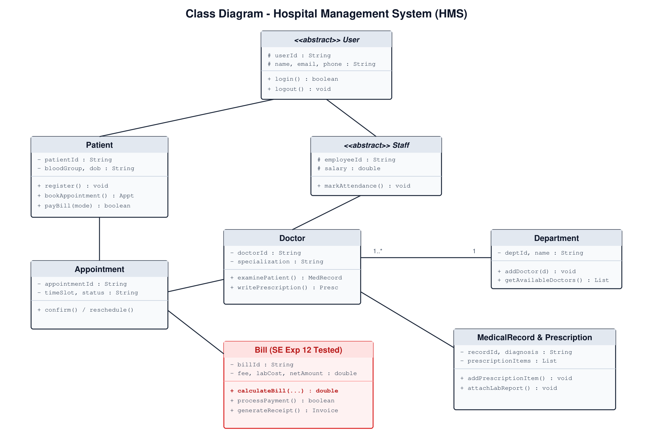
Fig 2: Class Diagram - Hospital Management System (Static Architectural Model)
Relationship Definitions & Justifications:
1. Generalization / Inheritance (User hierarchy):
• abstract class User is inherited by Patient and Staff.
• abstract class Staff is inherited by Doctor, Receptionist, Pharmacist, LabTechnician, and Administrator. All share common authentication attributes while encapsulating specialized operations.
2. Aggregation (Hollow Diamond: Department o-- Doctor):
• Represents a 'has-a' weak ownership relationship. Doctors belong to a Department (e.g., Cardiology, Orthopedics). If a Department is reorganized or dissolved, Doctor objects continue to exist independently within the hospital system.
3. Composition (Filled Diamond: MedicalRecord *-- Prescription, Bill *-- BillItem):
• Represents a strong whole-part lifecycle dependency. A Prescription cannot exist independently outside a MedicalRecord; deleting the medical record deletes associated prescriptions. Similarly, individual BillItem line items cannot exist without their parent Bill.
4. Multiplicity & Associations:
• Patient (1) ➔ (0..*) Appointment: A registered patient may book multiple appointments over time.
• Appointment (1) ➔ (1) Bill: Every confirmed appointment generates exactly one consolidated billing account.
5. Conclusion
The Use Case and Class diagrams together define the functional requirements and object-oriented structure of HMS. The careful use of aggregation, composition, and inheritance provides high maintainability and loose coupling across hospital modules.

